**An Inventory Management System Software For**

**URR Allied Medica Corporation**

A Proposed Study

Presented to the Faculty of the

College of Information Technology and Computer Science

University of the Cordilleras

In Partial Fulfillment

of the Requirement for the Course

CC13 SYSTEMS ANALYSIS AND DESIGN

Submitted by

As-il, Jhaeus Herzian T.

Baleña, Julius Bernadin S.

Castillo, John Ariel Dominic J.

July 19, 2019

**Acknowledgement**

The researchers would like to express their appreciation to their families, classmates, teachers, and God.

They would like to offer my special thanks to Ma’am Joan Peralta. The advice given by her has been a great help in our study.

They would like to thank the URR Allied Medica Corporation for their cooperation for the study.

Their special thanks are extended to Dr. Ruiz for accepting to participate in the study.

**Table of Contents**

**Chapter 1…………………………………………………………………………………………………………………………………………**4

Background of the Study………………………………………………………………………………………………….4

Company Profile…………………………………………………………………………………………………………………………5

Figure 1…………………………………………………………………………………………………………………………….5

Objectives of the Study………………………………………………………………………………………………….7

**Chapter 2………………………………………………………………………………………………………………………………………**…8

Software Development Methodology……………………………………………………………….8

Project Planning………………………………………….………………………………………………………….8

Figure 2………………………………………….……………………………………………………………………8

Figure 3………………………………………….……………………………………………………………………9

Figure 4………………………………………….……………………………………………………………………9

Analysis………………………………………….……………………………………………………………………………….9

Design………………………………………….……………………………………………………………………………………10

Implementation………………………………………….………………………………………………………………10

Scope and Delimitations of the Study…………………………………….10

Systems Analysis and Design Tools…………………………………….11

**Chapter 3………………………………………………………………………………………………………………………………………**12

Current Process of the Inventory Management System………….12

Figure 5………………………………………………………………………………………………………………12

Figure 6………………………………………………………………………………………………………………13

Problems Encountered in the Current Inventory Management System……………………………………………………………………………………………………………………………….13

Figure 7…………………………………………………………………………………………………………….14

Feature of the Proposed Inventory Management System……….14

Logical Design…………………………………………………………………………………………….14

Figure 8……………………………………………………………………………………………….15

Figure 9……………………………………………………………………………………………….15

Figure 10………………………………………………………………………………………………16

Figure 11………………………………………………………………………………………………16

Physical Design……………………………………………………………………………………………17

Figure 12………………………………………………………………………………………………17

Figure 13………………………………………………………………………………………………17

Figure 14………………………………………………………………………………………………18

Figure 15………………………………………………………………………………………………18

Figure 16………………………………………………………………………………………………18

Figure 17………………………………………………………………………………………………19

Figure 18………………………………………………………………………………………………19

Figure 19………………………………………………………………………………………………19

Cost Benefit Analysis………………………………………………………………………….20

Table 1………………………………………………………………………………………………….20

Table 2………………………………………………………………………………………………….21

Table 3………………………………………………………………………………………………….21

**Chapter 4………………………………………………………………………………………………………………………………………**23

Conclusion………………………………………………………………………………………………………………………23

Recommendation……………………………………………………………………………………………………………23

Appendices…………………………………………………………………………………………………………………….24

**Chapter 1**

1. Background of the Study

Clinical and Medical Laboratories are establishments that are capable of running diagnostic tests on tissue, blood, etc. for their patients. Their processes are subdivided into pathology, serology, histology, virology, bacteriology, and molecular biology. (Exilab, 2019)

Laboratory/Clinical scientists discover the presence or absence of disease and provide data for physicians to use the best treatment for their patients. (Explore Health Careers, 2019)

Inventory Management System is a combination of hardware and software technology and methods that control the monitoring and maintenance of stocked products whether these are company property, raw materials and supplies, or products that will be delivered to vendors or consumers. (Camcode, 2019)

When starting a new laboratory or simplifying inventory the inventory process it is important to create a starting point. Everything must be taken stock by either writing it down or filing it in a software. Everything must be accounted for with either choice. With that completed, deciding and dividing the stocks based on significance should be done after. (Lab Manager, 2015)

Medical equipment manufacturers rely on Inventory Management Software to support inventory planning. A strong software can take care of inventory, purchases, sales, orders, payments which in turn protects the company from potential damage. (Noble House, 2017)

1. **Company Profile**

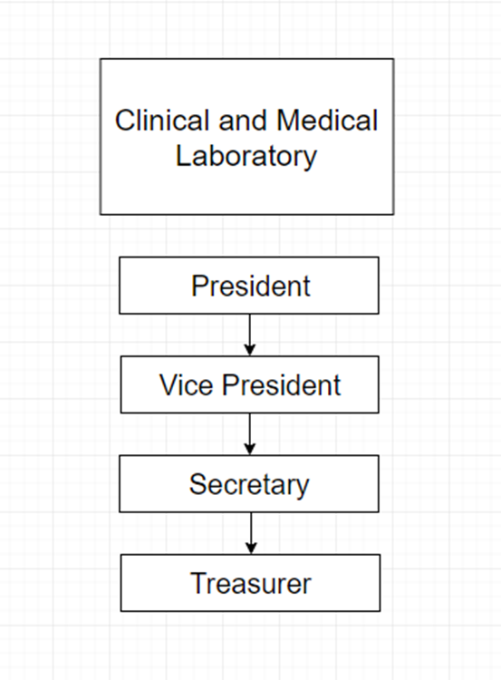

Figure 1 Organizational Chart

The corporation’s industry is a Medical Laboratory. URR Allied Medica Corporation handles a quite the variety of services for caring and aiding clients’ health concerns. These services include blood chemistry, cytology, parasitology, drug testing and analysis, x-rays, and medical consultations.

The corporation’s vision is:

“Envisions to be the holistic laboratory clinic providing accurate diagnostic services and to be empowered by god with caring health care professionals.”

The corporation’s mission is:

“Our advocacy is to care for people from all walks of life. Desires to add value to the quality of our client's life by aiding them in their health concerns and by offering reliable laboratory services.”

URR Allied Medica Corporation started out as a clinic and pharmacy. It was established during the month of September around the year of 2005. Corporation’s family consisted of members that were medical allies which lead to the creation of their laboratory branch 10 years after.

The corporation operates as a Medical Laboratory, Pharmacy, and Medical Consultation. As a laboratory the corporation handles a wide variety of medical services in order to help their clientele. Blood chemistry, cytology, parasitology, drug testing and analysis, and x-rays are all manned by professionals. The corporation also distributes medicinal products that are supplied by world trusted companies. Though their supplies are incomparable to big drug stores, they manage to go by through selling basic medical products. The corporation is capable of giving consultations to their clients. Their family is composed of professional and trained medical allies.

1. **Objectives of the Study**

The objective of this study is to implement an inventory system for the URR Allied Medica Corporation, a local pharmacy that manages a small medical laboratory. The system will be using the concept of the ABC inventory or Pareto Principle. Small businesses can better manage their inventory at the same time save more in the long run. The principle also states that 80% of the sales come from 20% of the clients. This would also mean that 20% of the inventory makes up 80% of the overall volume.

**Specific Objectives**

1. To identify the existing process of Laboratory Inventory Management System in the URR Allied Medica Corporation.

2. To identify the problems encountered in the Laboratory Inventory Management System in the URR Allied Medica Corporation.

3. To design the features of the proposed Laboratory Inventory Management System the system for the URR Allied Medica Corporation

**Chapter 2**

1. **Software Development Methodology**

This chapter will discuss the research SDLC Process, Project Planning, Analysis; Design, Implementation, Scope and Delimitations of the Study, and Systems Analysis and Design Tools.

1. **Project Planning**

The goals of the project planning include establishing the scope of the system that will be integrated, project feasibility, and schedule development.

The deliverable for this phase will be WBS Chart, Gantt Chart and, Pert Chart.

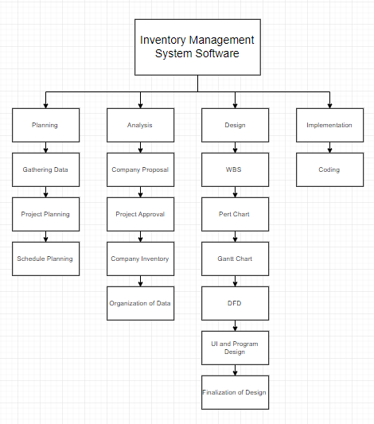

Figure 2 WBS

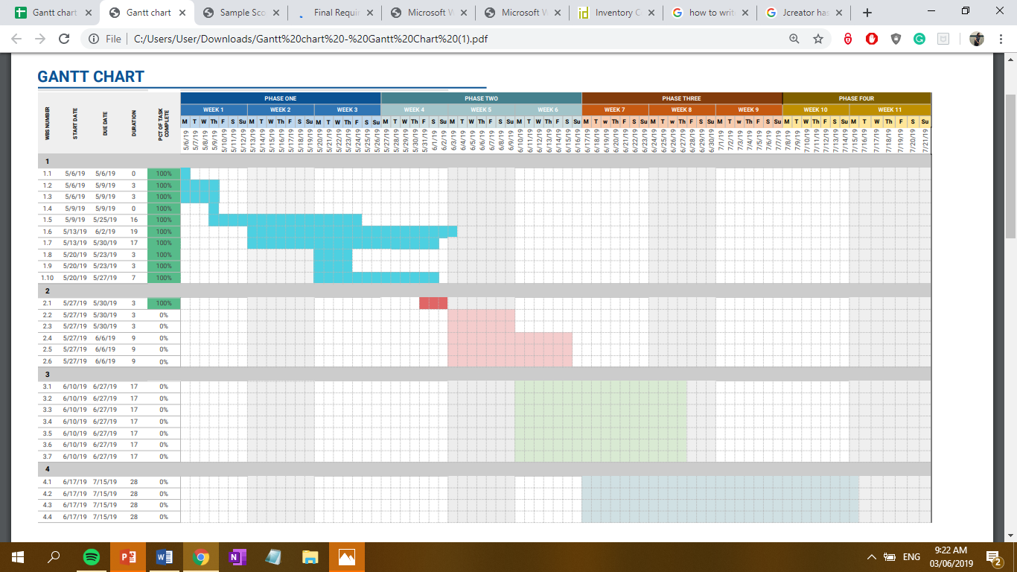

Figure 3 Gantt Chart

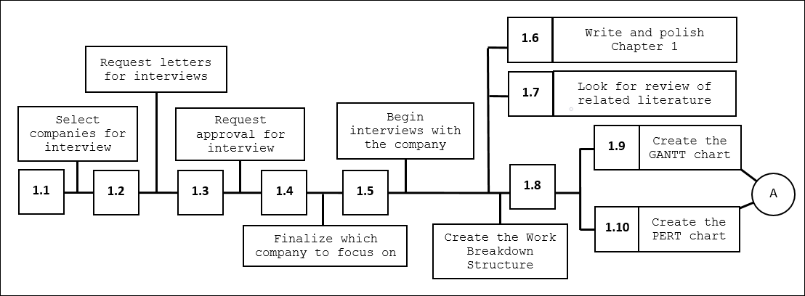

Figure 4 Pert Chart

1. **Analysis**

The objectives of the analysis are to comprehend and file the necessities of the corporation and to process the requirements for system to be integrated.

The deliverables for this phase will be the documentation and the System requirements.

1. **Design**

The design requires to create plan solutions that were established in the analysis phase.

The deliverables for this phase are the User Interface and a prototype.

1. **Implementation**

This phase deals with the construction, experimentation, and integration of the planned system with the end goal of aiding the organization.

1. **Scope and Delimitations of the Study**

This study is focused around the development of an inventory management system that will give ease to the organization’s users which in turn will allow allocation of time to other tasks. The system will be installed in a computer without depending on the internet or other programs.

The corporation functions as a clinic, pharmacy, and laboratory. The clinic provides medical consultation for their clients. The pharmacy distributes basic medicinal commodities for the clients. The laboratory handles client samples for analysis. The study will be centralized around the laboratory.

The system will only be accessible to organization members for utilization of inventory.

1. **Systems Analysis and Development Tools**

The list of tools that will be used in developing the inventory management system are Draw.io: a Google Drive integrated system that enables the user to create flowcharts, UMLs, entity relations, network diagrams, etc., Microsoft Project: a project management software that assists users in creating schedules, assigning resources to tasks, budget management, and workload analyzation, Netbeans(Java): an integrated development environment allowing the development of applications from a set of modular software components called modules.

**Chapter 3**

1. **Current Process of the Inventory Management System**

The medical technicians will request a list of all laboratory equipment. If the list is not given then a request will be sent again. They will check the list for items that are in inventory. Every ordered item will be documented on an item and chemical file. The medical worker will then keep stock of the received equipment and record it in an inventory file.

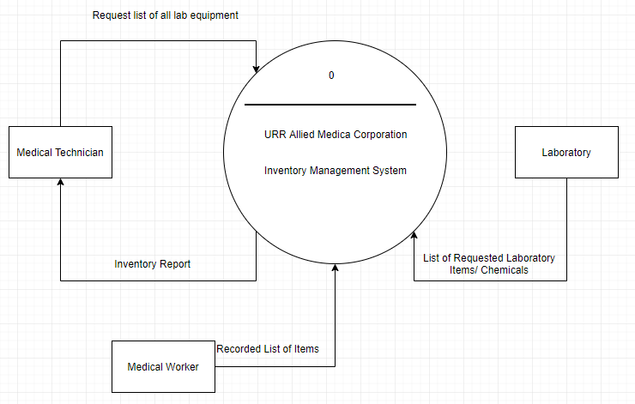

Figure 5 Context Diagram

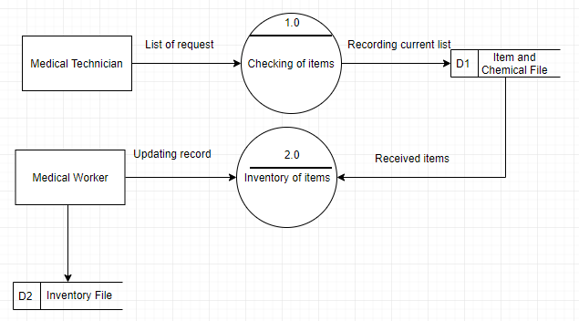

Figure 6 Top Level Diagram

1. **Problems Encountered in the Current Inventory Management System**

The current inventory system is not being utilized properly at all. Their method of recording entries is done traditionally using a log book, which can be very tedious. The inventory’s entries are not consistent because it is not checked and updated by the staff.

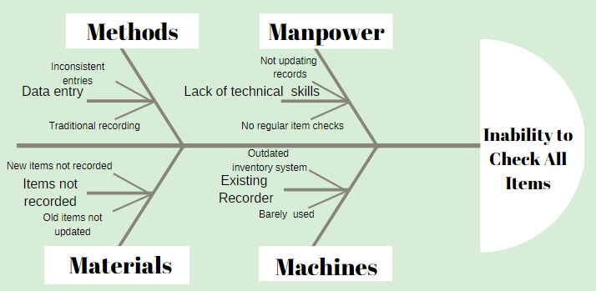

Figure 7 Ishikawa Diagram

1. **Features of the Proposed Inventory Management System**
2. **Logical Design**

The proposed Inventory Management System will be a software that will features such as Request List of All Items, Checking of Items, Record All Received Items, and Add Delete and Update Record.

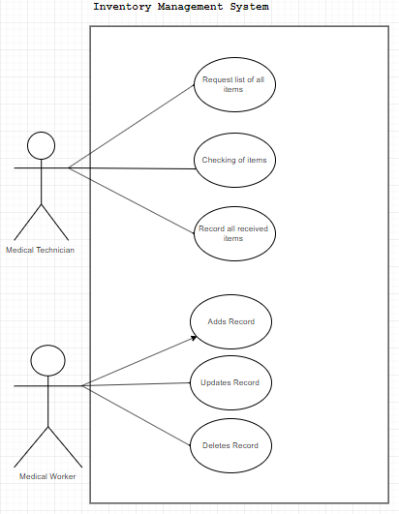

Figure 8 Use Case Diagram

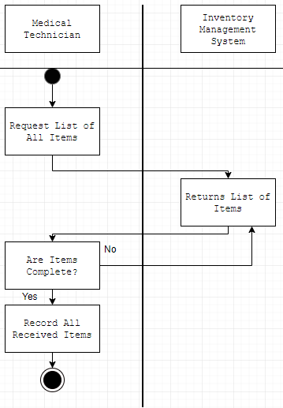

Figure 9 Activity Diagram

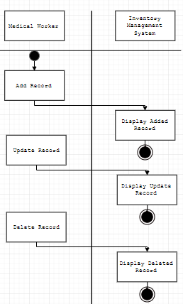

Figure 10 Activity Diagram

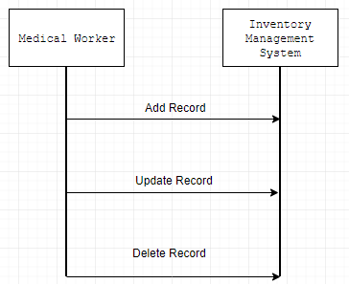

Figure 11 Sequence Diagram

1. **Physical Design**

The software will have design inspirations from medical institutions using red, blue, and white as the color palette. It features easy mapping of tasks and interactable buttons. Users can add and update photos of the item, its code, and its description. When deleting, a search bar is provided for ease. It also has a warning alert in order to ensure that the user does not make mistakes. Lastly, the user can display the records.



Figure 12 Flash Screen

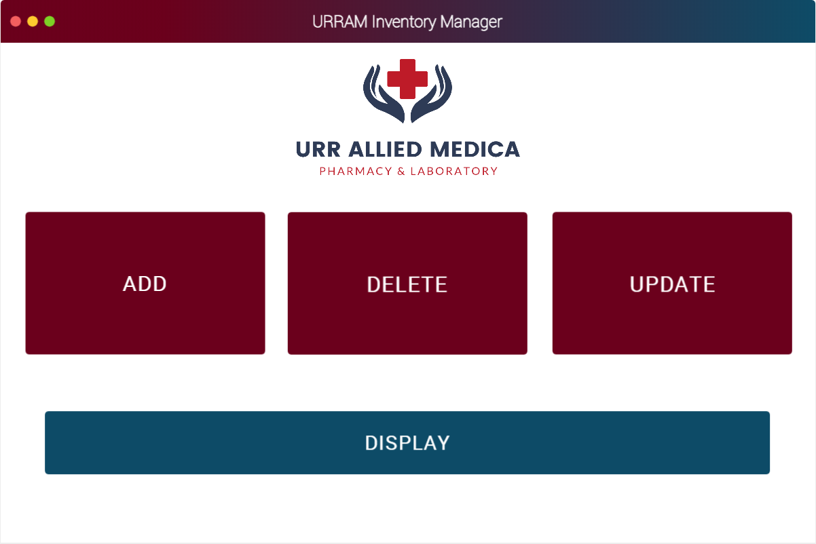

Figure 13 Main Menu

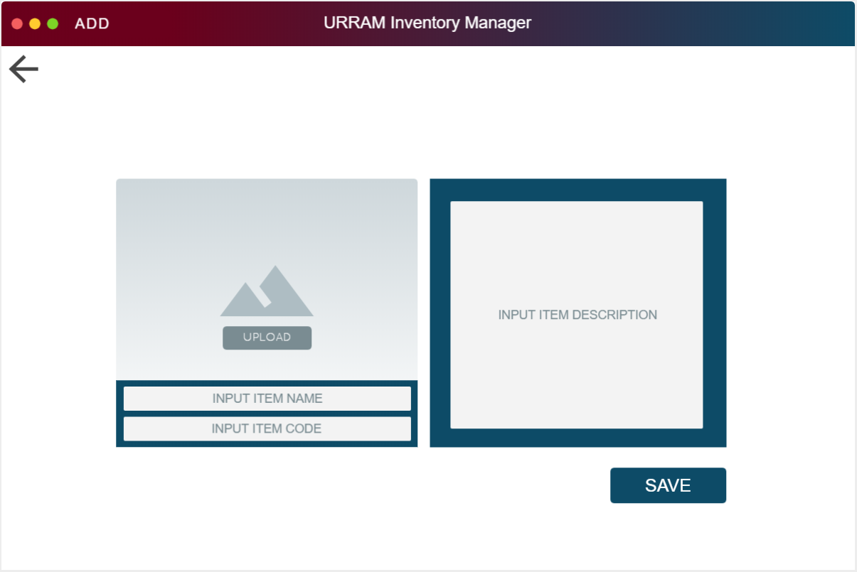

Figure 14 Add Records

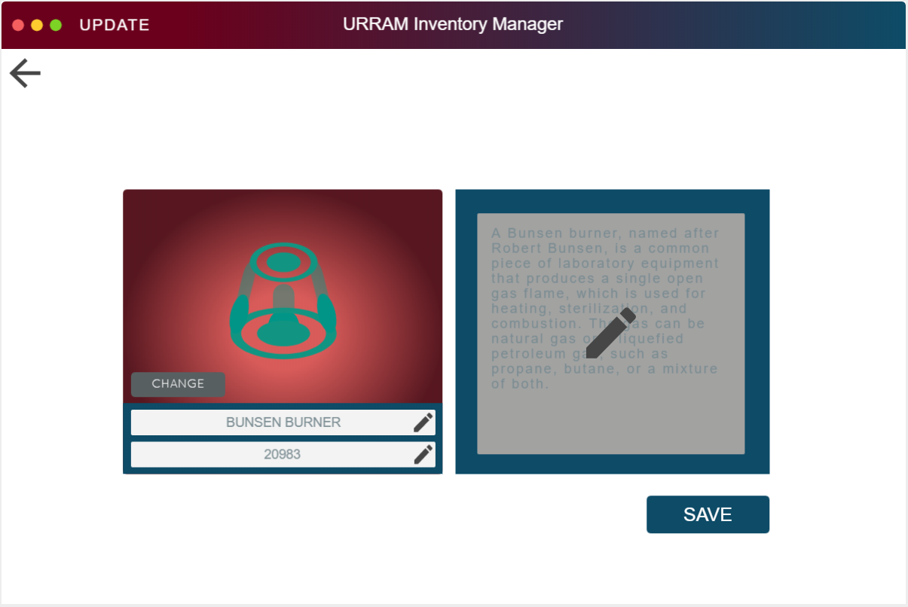

Figure 15 Update Records

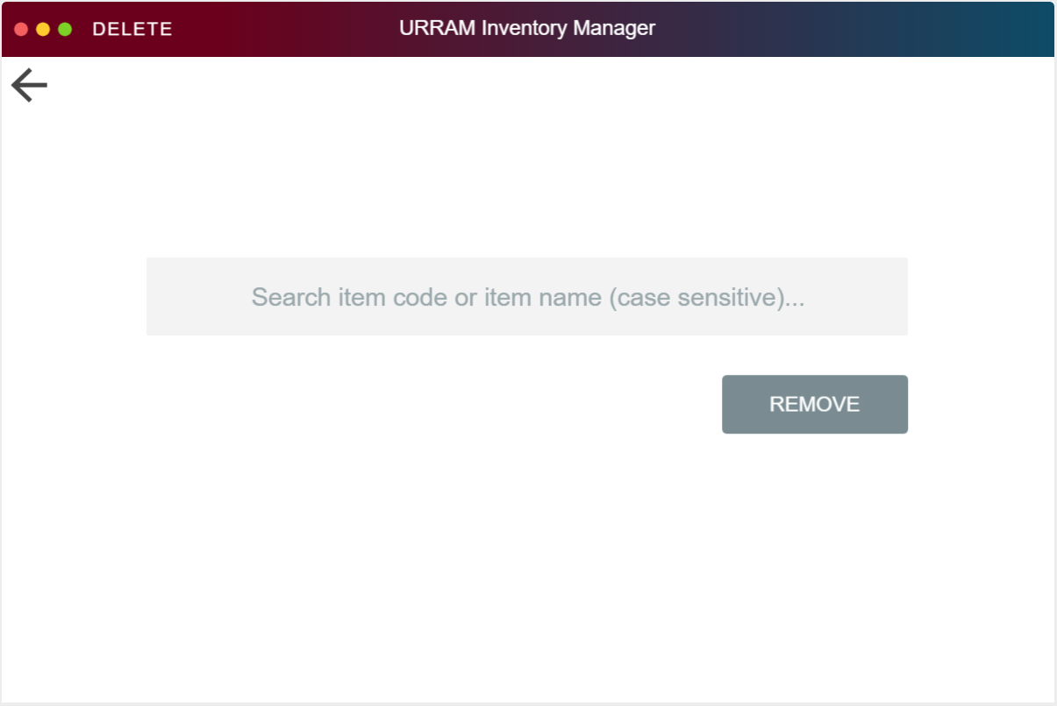

Figure 16 Delete Records

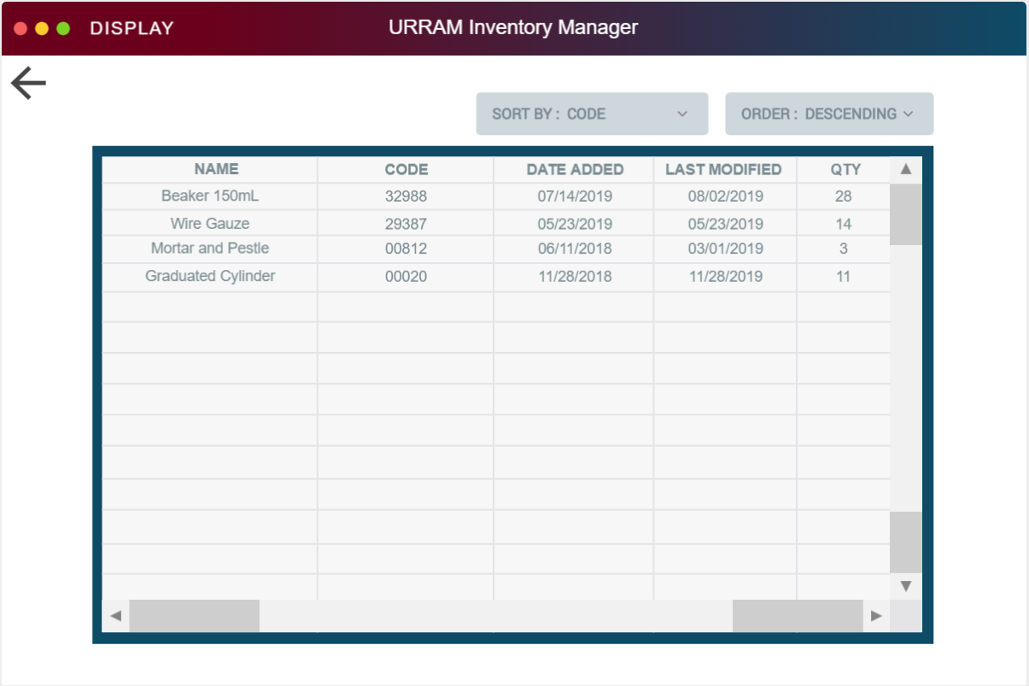

Figure 17 Display Record

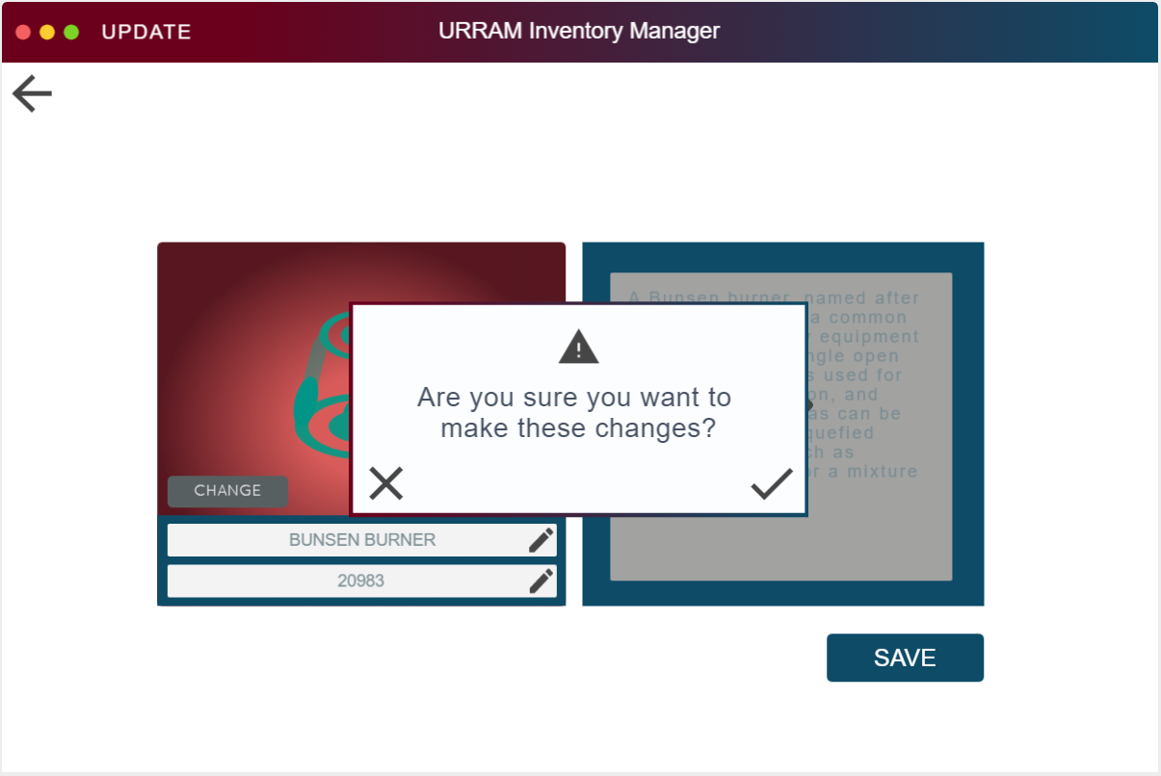

Figure 18 Update Warning

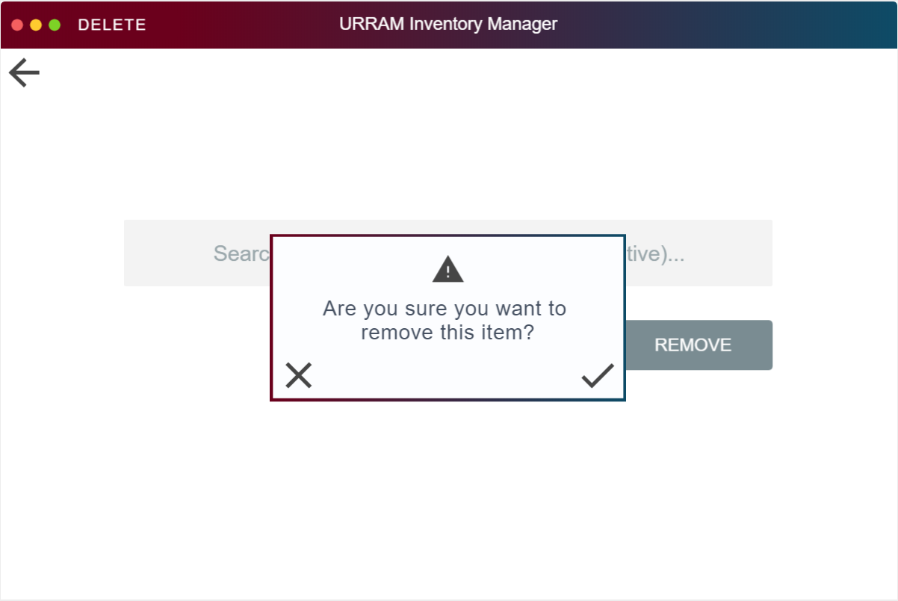

Figure 19 Delete Warning

1. **Cost Benefit Analysis**
2. **Development Cost**

The table shows estimates of the development cost of the team from the equipment needed for the new system to the professional fee of the developers. The costs estimate of the new computer were gathered from current average value of parts from retail shops that are found here in Baguio. The professional fee is based on the average annual salary of freelancer software developers. The software is based on the prices of software created by amateurs.

|  |  |  |
| --- | --- | --- |
| New Computer | 1 pc. | 10,000.00 |
| Professional Fee | 1 lot | 9,000.00 |
| Software | 1 pc. | 15,000.00 |
| **Total** |  | **34,000.00** |

Table 1

1. **Operating Cost**
2. Existing Operating Cost (EOC)

This table shows the current EOC of the corporation. The estimate of the salaries is based of averages of medical workers. The salary estimate is based on the annual hourly rate of medical workers. The overtime is based on average working weeks of medical workers. The office supply is based on the corporation’s materials used for recording their data.

|  |  |
| --- | --- |
| Salaries | 176,400.00 |
| Overtime | 9,600.00 |
| Office Supply | 300.00 |
| Maintenance | 0.00 |
| Utilities | 0.00 |
| **Total** | **186,300.00** |

Table 2

1. Proposed Operating Cost (POC)

This is the POC of the researchers. The salary estimate remains the same however the overtime and office supply costs have been reduced to nothing because of the implementation of the new system. With the new system however, the utility cost an added estimate value because it requires electricity to function. The estimate is based on Baguio’s average annual cost of the electric bill of the computer and monitor.

|  |  |
| --- | --- |
| Salaries | 176,400.00 |
| Overtime | 0.00 |
| Office Supply | 0.00 |
| Maintenance | 0.00 |
| Utilities | 300.00 |
| **Total** | **176,700.00** |

Table 3

1. **Comparative Present Value Table**

This table shows how long the corporation will wait in order to reach the value of the Development Cost in order to determine if the new system should still be implemented in the following years.

|  |  |  |  |  |  |
| --- | --- | --- | --- | --- | --- |
| Year(n) | Savings (Sn) | Interest | Present Value (PV) | Cumulative PV (CPV) | Mark |
| 1 | 9,700 | 1.20 | 8,083.33 | 8,083.33 | X |
| 2 | 9,700 | 1.44 | 6,736.11 | 14,819.44 | X |
| 3 | 9,700 | 1.73 | 5,606.94 | 20,426.38 | X |
| 4 | 9,700 | 2.07 | 4,685.99 | 25,112.37 | X |
| 5 | 9,700 | 2.49 | 3,895.58 | 29,007.95 | X |
| 6 | 9,700 | 2.99 | 3,244.15 | 32,252.10 | X |
| **7** | **9,700** | **3.58** | **2,709.50** | **34,961.60** | **✓** |

*Annual Interest Rate = 20%

**Pay Back Period = 6 years, 7 Months, 20 days**

The PBP suggests that there is Gain with the new system.

**Net Present Value = 961.6**

**Return on Investment = 2.82%**

**Chapter 4**

**Conclusion**

The researchers have concluded the following to answer the objectives:

1. The existing inventory management system of URR Allied Medica Corporation is the traditional logbook system.
2. The problems encountered with the current URR Allied Medica Corporation is that it is outdated. The workers lack the technical skills for recording, the data entries are all outdated, the recording tools are traditional, and the items are not always recorded.
3. The features added in the inventory management system is the request list of all items, checking of items, recording of all received items, add records, update records, and delete records.

**Recommendations**

The researchers suggest to use the new Inventory Management System for the next few years.

**Appendices**

**Appendix A Communication Letter**

May 18, 2019

**Rochelle Ann R. Ruiz**

Joan Peralta

University of the Cordilleras-Main

Baguio City

Dear **Ms. Ruiz:**

In partial fulfillment of the requirements for the course CC13 Systems Analysis and Design, students are required to undertake a study that involves the analysis and design of an information system. This undertaking is intended to expose students to actual practices in system development.

In line with the above, we wish to request approval from your office for us to study your existing **Inventory System**. Should this request be approved, data-gathering activities will be conducted at a time deemed most convenient for you. All data gathered will be used strictly for academic purposes only, and will be treated with utmost confidentiality.

We look forward to a positive response.

Sincerely yours,

**John Ariel Dominic J. Castillo**

Project Leader

Noted:

**Joan M. Peralta**

Adviser, CC13